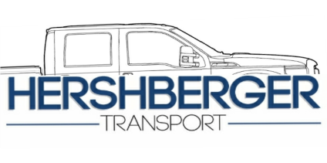 | HERSHBERGER  TRANSPORT  LLC

Account Application

Applicant Company Information
Full Company Name: |  |  |  | Date:
 |  | Company Name |  |  | xx-xx-xxxx

Office Address:

Street Address

 | City | State | ZIP Code

Office  Phone: |  | Office  Email

Additional Information:
i.e.: Start Date desired/ Load Frequency Info
Are You the Owner of this Company? | YES | NO

Are You the Primary contact source for H.T.? | YES | NO | If No, who?

Phone:

Additional Info
Warehouse or pickup/delivery locations
Contact Name: |  | Phone:
Company: |  | Location Type:
Address:
Contact Name: |  | Phone :
Company: |  | Location Type:
Address:
Contact Name: |  | Phone:
Company: |  | Location Type:
Address:

Cargo Description
Cargo Name: |  | Est.Weight:
Description: |  | Oversize?:

Cargo Insurance
Provider:

Insurance Rep: |  | Phone:

Other Notes:

Disclaimer and Signature
I certify that my answers are true and complete to the best of my knowledge.
Though Hershberger Transport is fully insured, Any cargo insurance through the above company will be collected first.
Signature: |  | Date:

Signature: |  | Date:
Andrew Hershberger (Owner)

